

T1040**(E)**(A11)T

**APRIL EXAMINATION NATIONAL CERTIFICATE**

# MECHANOTECHNICS N4

(8190194)

## 11 April 2016 (X-Paper) 9:00–12:00

**This question paper consists of 6 pages and 1 formula sheet of 3 pages.**

Please turn over

-2- T1040**(E)**(A11)T

## DEPARTMENT OF HIGHER EDUCATION AND TRAINING REPUBLIC OF SOUTH AFRICA

NATIONAL CERTIFICATE

MECHANOTECHNICS N4

TIME: 3 HOURS

MARKS: 100



### INSTRUCTIONS AND INFORMATION

1. Answer ALL the questions.

1. Read ALL the questions carefully.

1. Number the answers according to the numbering system used in this question paper.

1. Candidates are hereby advised to produce good sketches.

1. ALL the work done in pencil excluding sketches, drawings and diagrams will be regarded as rough work and will NOT be marked.

1. Write neatly and legibly.

Please turn over

### QUESTION 1

1.1 State TEN principles for good workshop layout. (10)

1.2 State THREE possible causes for each of the following faults that can happen in the spray process:

 1.2.1 Excessive paint spray

1.2.2 Uneven spray-painting

1.2.3 Sagging surface

1.2.4 Speckle or orange-peel effect

(4 × 3) (12)

1.3 Name THREE general methods of lubrication (3)

1.4 Make a labeled drawing of a siphon and wick lubricator which can be used for

lubricating machine parts. (5)

**[30]**

### QUESTION 2

The thickness of a 4-ply leather belt is 13 mm, it transmits 45 kW from a pulley that is 1,3 m in diameter and the speed of this pulley is 255 r/min. The contact angle is 172° and the coefficient of friction between the belt and the pulley is 0,27. The mass of the belt is 9,75 kg/m and the maximum allowable tension is 8 kN/m width per ply.

Determine the following:

2.1Belt speed (2)

2.2 Centrifugal tension in the belt (2)

2.3 Tension in the tight side per width (2)

2.4 Tension in the slack side (4)

2.5 Power transmitted by 1 m belt width (2)

2.6 Belt width

GIVEN: w = total power/power per width (2)

**[14]**

### QUESTION 3

FIGURE 1 shows the setup of the cutting tool that is held in the tool holder of a shaping machine.

The ram of the shaping machine has a mass of 150 kg and is operating with a cutting stroke length of 150 mm. The total work done during one cutting stroke is equal to ~~175 J and the coefficient of friction between the ram and the slides is 0,3.~~

Calculate the following:

3.1 The work done to overcome the friction between the ram and the slides. (3)

3.2 The cutting force exerted on the cutting tool. (3)

3.3 The forces exerted on the two contact points A and B if the clamping force in

the clamping screw is 2 000 N. (8)

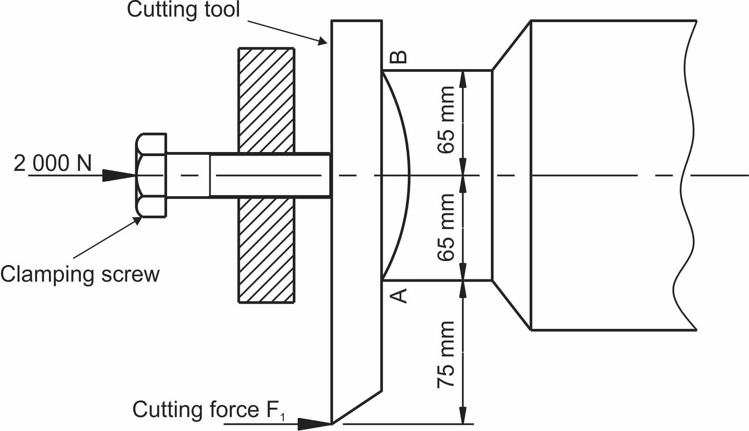

**[14]**

|  |  |  |  |
| --- | --- | --- | --- |
|  |  |  |  |
|  | **FIGURE 1** |  |  |
| **QUESTION 4** |  |  |  |
| 4.1 | An ISO screw thread with a 3,5 mm pitch has an effective diameter of 30 mm. The three-wire method is used for checking the effective diameter. The best wire size method is used for the test wires.    Calculate the micrometer reading over the three wires. |  | (5) |

Please turn over

4.2 4.2.1 Explain step-by-step how you would go about checking the correctness of the teeth of a gear wheel that has a module of 10 mm and a pressure angle of 20°. Use a gear tooth vernier calliper and apply the constant-chord method of checking. (4)

4.2.2 Make the necessary calculations for the test explained in

QUESTION 4.2.1 by using the constant-chord method of checking. (5)

 **[14]**

### QUESTION 5

5.1 An epicyclical gear train shown in FIGURE 2 consists of an annulus A having 130 teeth, a sun gear B having 40 teeth and a planetary gear C having 50 teeth that are mounted on arm D.

|  |  |  |  |  |  |
| --- | --- | --- | --- | --- | --- |
| **NR** | **CONDITIONS** | **A** | **B** | **C** | **ARM D** |
| 1 | Fix arm D and rotates A = + 1 rev |  |  |  | 0 |
| 2 | Multiply by x and add y | x+y |  |  | y |

Make use of the conditions given in the table above to calculate the following:

5.1.1 The velocity ratio of sun gear B (1)

5.1.2 The velocity ratio of planetary gear C (1)

5.1.3 The speed of planetary gear C when annulus A is fixed and arm D

rotated at 50 r/min (4)

5.1.4 The speed of annulus A when sun gear B is fixed and arm D

rotates at 30 r/min (4)

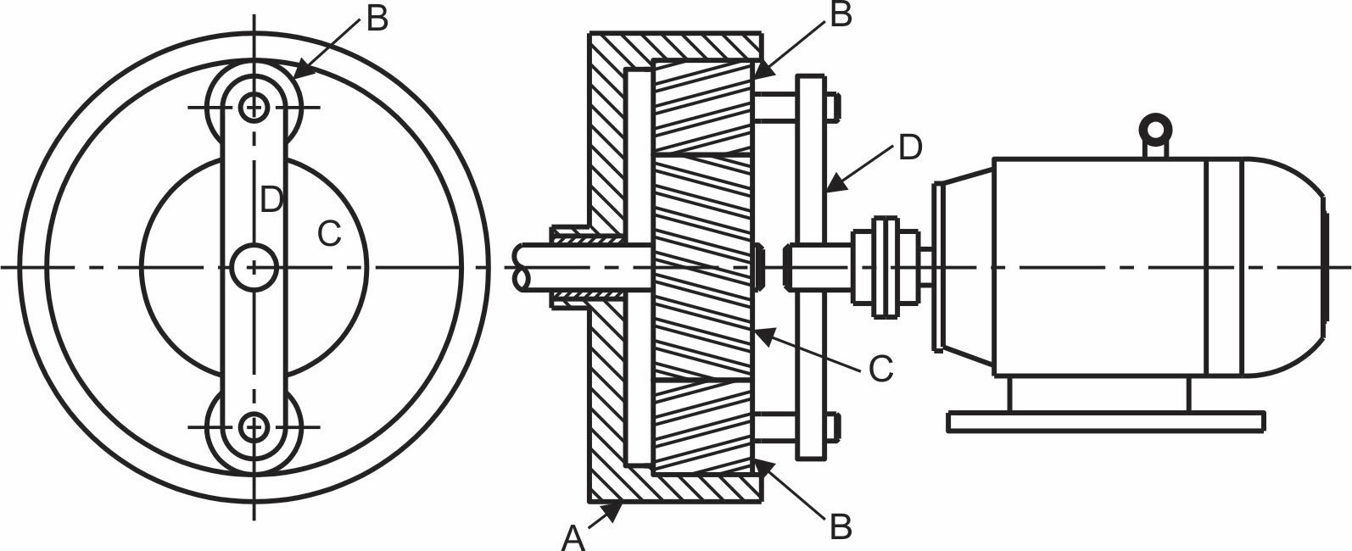

### FIGURE 2

-6-

5.2 A set of spur gears have a velocity ratio of 5 : 3 and a module of 6 mm if the pinion has 30 teeth.

Calculate the pitch diameter of both gears. (4)

**[14]**

### QUESTION 6

6.1 Determine the flow rate of water in litres per second (ℓ/s) flowing through a 200 mm diameter pipe equipped with a Venturi meter that has a throat diameter of 130 mm. The coefficient of delivery is 0,97 and the mercury

manometer shows a reading of 880 mm. (7)

6.2 Water with a density of 1 000 kg/m3 flows through a tapered pipe which has a large diameter of 0,4 m and a small diameter of 0,2 m. The pressure gauge at the small diameter of the pipe is 16 kPa and the velocity of flow at the small diameter is 20 m/s.

Calculate the pressure at the larger diameter of the pipe (7)

**[14]**

**TOTAL:** **100**

--71--

### MECHANOTECHNICS N4

**FORMULA SHEET**



*.*

*1*

*3*

*.*

*2*

*. DO = m × (T +*

*2)*

*.*

*4*

*T*

*PCD*

*m*

=

*)*

*TB*

*TA*

*(*

*m*

*C*

+

´

=

2

2

2

1

*mv*

*Ke*

=

*TA*

*5. VR*=  *PCD of gear*

*TB 6. VR* =

*PCD of pinion*

*7. VR*= *NBNA 8. NA × TA = NB × TB*

2´*T*

*9. Ft* =

*PCD 10. Fr = Ft × Tan*f

1. *Fn = Ft × Sec*f

1. *Ie = IA + (VR)2 IB + (VR)2 IC + (VR)2 ID*

|  |  |  |  |  |  |  |  |  |  |  |  |  |  |  |
| --- | --- | --- | --- | --- | --- | --- | --- | --- | --- | --- | --- | --- | --- | --- |
| *13. T*    *15.*    *17.*    *19*      *21*    *23.* | " *=*  *NB*  *NA*  *P*=  *. v =* p | =  p  *. TA = TS + 2TP* | *Ie ×* w w  ´ | *B*  *A*  *n*  q | "  =  *PCD* | *A* a*B* a*A*      *× (d + t) × N* | = | *IA*  *IB* |  | *14.*    *16.*      *18*    *20.*    *22*      *24* | *T*a  *T*  *. T1 =* | =  *Input*  *Output*  *. P = Te × v* | *TA* +  =  *OUTPUT TINPUT*  *. Ti + To + Th = 0*  *speed*  = *speed* | *TBC (ND) TD*  + h1 *(NA)* h1h2  ´*GR*´*η*    *Teeth on driven gears*    *Teeth on driving gears* |
| *T*1  = *T*2 | *e*µ | |
| * *× A* | |
| - | | | |
| *25* | *. Tc = m × v* | *2* | | *T*1 *TC*  *26.* =*e*µq*cosec*a  *T*2-*TC* | | | | |

1. *L*=p´ (*D*+*d*)+ (*D*±*d*)2 +2*C*

2 4´*C*

1. *Tg = m × g × sin*f *29. v =* T *× r*

--82--



*.*

*30*

*.*

*32*

*.*

*34*

*31*

*.*

*33*

*.*

*.*

*35*

*r*

*g*

*v*

´

´

=

µ

ú

û

ù

ê

ë

é

-

+

=

q

µ

q

µ

*Tan*

*Tan*

*gr*

*v*

1

*n*

*Tan*

*Tan*

*T*

*T*

ú

û

ù

ê

ë

é

-

+

=

q

µ

q

µ

1

1

2

1

*h*

*r*

*b*

*g*

*v*

´

´

´

=

2

ú

û

ù

ê

ë

é

-

+

=

q

q

*tan*

*/*

*b*

*h*

*/*

*b*

*hTan*

*gr*

*v*

2

2

*C*

*r*

*R*

*Cos*

-

=

2

q

*36. Cos*f= *R* + *r*

2 *C*

*38. T1 = w × n × ft*

*40. t* = *I* ´w *T*

*42. T = F × r*

*44. do = de + 0,65P*

1. *h* = *m*éêë1-p4 (*sin*q*Cos*q)ùúû

*p*1 *(v*1*)*2 *p*2 *(v*2*)*2

1. + + *gh*1= + + *gh*2

*Rho* 2 *Rho* 2

*gx*2

1. *Vw(Va)* =

2*y*

*50. hf* = 4´ *f* ´!´*v*2

2´ *g* ´*d*

*Cd* ´ *A*´ *a*´ *(*2*gh)*

*52. Q* =

*( A*2 - *a*2 *)*

*54. V* = *(g* ´ *R*´*Cos*q*)*

*56. L = 2C +* p*D*

*m*2´*g*´*S*

*58. One load =*

4´*h*

*37. m = w × t × L ×* D

*39. P = Pg + Pµ*

*41. P*= 2´p´*N*´*T*

*60*

*43. w = do + 3d - 1,5155P*

p´*m* 2q*)*

*45. w*= *(cos*

2

*49. v* = *C mi*

*51. hf* = *f* ´!´ *O*2

*3,026* ´ *d*5

*(*2*gh)*

*53. Q* = *Cd* ´ *A*´

*(m*2 -1*)*

*m*´*s*

*55. Vol. bucket =* r´*v*

*m*1´*g*´*S*2

*57. Self-weight =*

8´*h*

*59. T (acc load) = (T1 - T2)R*

--93--

|  |  |  |  |  |  |  |  |
| --- | --- | --- | --- | --- | --- | --- | --- |
|  |  |  |  |  |  |  |  |
| 1. *T (acc drum) = I*        1. *P =* T *× T* | ´a= *mk* | 2´ | *a*    *R* | *62.*    *64.* | T *= 2*  *Ke* = | p *× N*  *work*  *efficiency* | *done* |

*63. Ke* =*I* ´w2 *66. (I1 + I2)*T*3 = I1*T*1 + I2*T*2*

|  |  |  |  |  |  |  |
| --- | --- | --- | --- | --- | --- | --- |
| *65*      *67*        *69*      *71*    *73.* | *. T = µ ×*  Fc | *. µ = Tan*  = mv | q    *. T = µ × n × (Fc*  2    g | *. P = Ke × operations/sec*  *F × Re × n*  *-* | *S)R* | *68.* h= *Tan*q *Tan(*q+f*)*    *70. T* = *F* ´*Re* µ´  *sin*q    *72. Fc = m ×* T *2 ×* g |

1. *Tractive effort = mass on driving wheels × µ × g*

1. *Side thrust = FcCos*q- *mg Sin*q

1. µ= *FcCos*q- *mgSin*q *mgCos*q+ *FcSin*q

1. *Pl* =*CmgL*+*mgh*